- 扫描以下二维码/Scan the following QR code
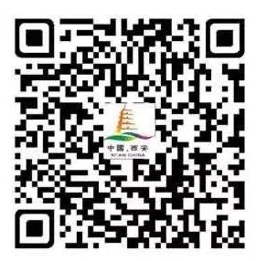
- 选择“身份信息登记”/Choose “身体信息登记”
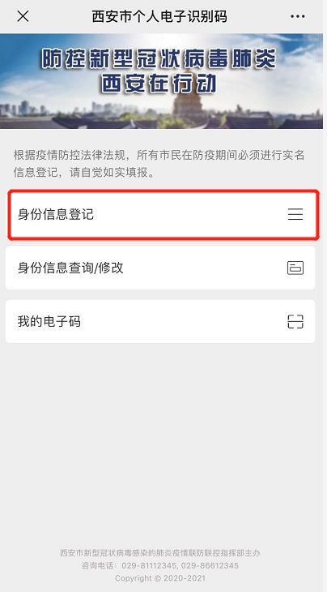
- 填写完整信息，即可生成二维码，记得要准确输入相关信息/Fill your personal information and you will obtain your own “One Code Pass”.
- 